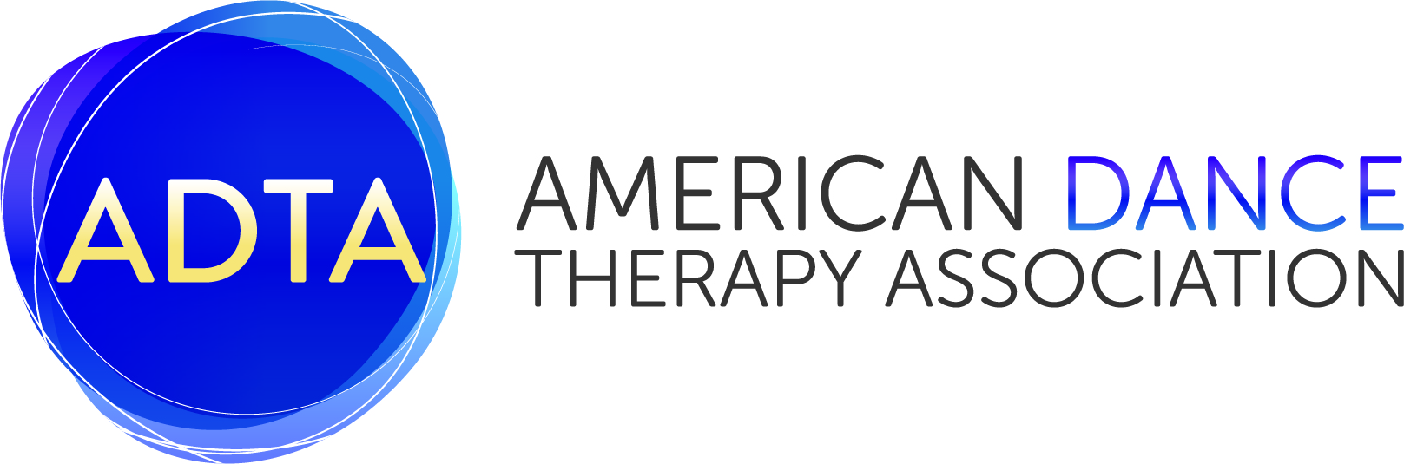

STANDARDS ROLLOUT
COMMITTEE ON APPROVAL PROCEDURES

ADTA Approval Procedures Governing the Period from
June 15, 2017 through December 31, 2022

I. Policies Governing Transitions to New Standards
1. Use of New Standards are Encouraged: When the ADTA implements new standards, programs are encouraged to move toward compliance with the new standards for education and clinical training; however, for approval matters, the ADTA will hold programs accountable to meeting the current ADTA education standards for approval.
2. Within six (6) years, by January 1st, 2023, all programs are in compliance with new ADTA Standards for Education and Clinical Training.

II. Policies Governing Maintenance of Approval Decisions during the Transition
- Timeline of Implementation
- Programs must continue to maintain compliance with current standards as most revised standards are more rigorous. Thus, moving into compliance with the revised standards does not jeopardize compliance with the current standards.
  - An exception is that internship standard 8.6 is more flexible in the revised standards, which would compromise compliance with the current standards. However, programs will not be penalized and will still be considered to be in compliance if they choose to implement this standard prior to January 1, 2023.
- Programs can implement revised standards within their own timeframe as long as all revised standards are implemented by January 1, 2023. All rollout plans and implementation of revised standards will be reported in the Annual Report to the Committee on Approval.

2. Annual Reports
1. The comprehensive annual reports are due February 15th of every year.
2. The report will capture compliance with current standards and cumulative progress towards bringing the program into compliance with new education and clinical training standards by December 31, 2022.
3. The year of the program’s six-year self-study report, no annual report is required.

Approved by the ADTA BOD April 2, 2017
Amendments Approved by the ADTA BOD August 21, 2017

